**How does it encourage creativity?**

Students choose to create projects in one of five categories:

* + Historical paper
  + Exhibit
  + Documentary
  + Performance
  + Website



**Where can I get more information?**

* [www.nationalhistoryday.org](http://www.nationalhistoryday.org) - has *everything* you will want/need to know about this contest, from topic ideas to specific contest rules!
* [www.noodletools.com](http://www.noodletools.com) - helps students correctly cite their research (Annotated List of Works Consulted)
* Your friendly History teacher - every social studies teacher at this school is trained to teach history fair, feel free to email with questions
* Help/Work sessions before school for students - keep eyes and ears posted for exact dates

**Example of an Exhibit:**

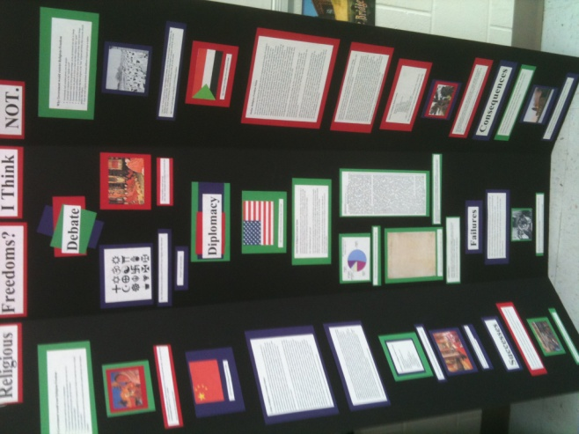

**Common Questions:**

* **Will I have support when I have questions?**

Your History teacher is more than happy to answer your questions.

Please check the teacher’s website

And encourage your student to

attend the before school help when it

is offered.

* **Is it a lot of work for the student and parent?**

If the student follows the due dates and does not procrastinate, they will succeed. The calendar break down doesn’t give too much work at one time.

**History Fair**

**at**

**D.M.S.**

*A Parent’s Guide*

*To Understanding History Fair*

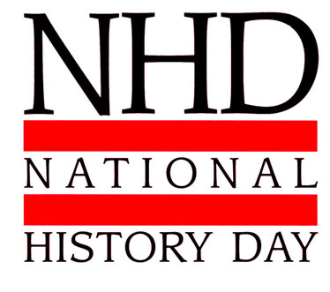

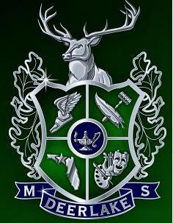

**Who participates:**

ALL 8th grade students



**What is it??**

A research based project in which students choose any topic in history that relates to the theme *Triumph & Tragedy in History*. The students conduct research using primary and secondary sources, as well as print and electronic sources. The students learn how to correctly cite sources using MLA Styling technique.

**This year’s theme:**

**Triumph & Tragedy in History**

**Due Dates*:**

**1st Semester:**

* Preliminary Topic due- Friday 9/21
* Official Topic due – Monday, 9/24
* Rough Draft Annotated Bibliography due- Friday 11/2
* Rough Draft Process Paper due- Thursday 11/8

**2nd Semester:**

* Final Draft Process Paper and Bibliography due- Friday 1/11
* Final Projects due – Wednesday, 1/18
* DMS History Fair Set-up –Monday, 1/28
* DMS History Fair Judging – Tuesday, 1/29
* Leon County History Fair – Thursday, 2/22

* Please note that the above dates are subject to change and may vary slightly according to a teacher’s specific calendar.

**Why??**

**TEACHES:** critical thinking, writing, and research skills and boosts performance across all subjects.

**INSPIRES:** students to do more than they ever thought they could.

**PREPARES:** students for college, career and citizenship.

**NHD students outperform their non-NHD peers on state standardized tests, not only in social studies, but in reading, science and math as well.** For example:

* In 2008–2009 in Texas, twice as many NHD students achieved “commended performance” as non-NHD students (87 percent vs. 37 percent) on the social studies assessment of the Texas Assessment of Knowledge and Skills (TAKS)
* At the South Carolina middle school where NHD was part of the curriculum for all eighth graders, students scored higher than students in the non-NHD middle school on the Language Arts, Math and Science segments of the 2008-09 PASS test.

**NHD students are better writers**, who write with a purpose and real voice, and marshal solid evidence to support their point of view. NHD students outscored comparison-group students on both pre- and post-writing assessments, receiving more high scores (5s or 6s) on a 6-point scale, and fewer low scores. NHD essays had more sentence variety, richer vocabulary, a more authentic voice, and better organization. (from NHD.org)